***DORAN-ABVM***

**EMERGENCY VENTILATOR PROPOSAL**

**JOHN DORAN (REV 3) 01JUN2020**

Contents

1.1. Automated Bag Valve Mask (ABVM) 3

1.2. Deliverables 4

1.3. Problem Definition 4

1.4. Design Requirements 4

1.5. Development Process Overview 5

1.6. Design by Best Idea (our Philosophy). 6

1.7. Open Source. 6

1.8. Bill of Materials (BOM) 7

**1.** **ABVM - THEORY OF OPERATION** 8

1.1. Control Panel. 8

1.2. Covers. 9

1.3. Volume and Force Adjustment Levers. 10

1.4. Tidal Volume Adjustment. 11

1.5. Force Adjustment. 12

. 14

1.6. Motor Assembly. 14

1.7. Bearing Assembly. 15

1.8. Limit Switch Operation. 16

**2.** **PROBLEMS TO BE SOLVED (HOW TO HELP)** 17

2.1. Overview of Problems. 17

2.2. Spring Selection. 17

2.3. Trip Switch and Levers´ Hard Stop Spacing. 17

2.4. Plastic Bag Cover (Hygiene) when covers not used. 17

2.5. Motor and Sensor Selection Guide. 17

2.6. Wiring Design Layout (Arcing Issues etc). 18

2.7. Method of Alarms (Patient Distress and ABVM). 18

2.8. Method of Patient Signal to Start BVM Compression. 18

2.9. Noise Control (Is noise an issue?). 18

2.10. Documentation: 2D and how-to-make Instructions. 19

2.11. Patient Requirements in a breathing Emergency (Guidelines for Design). 19

2.12. Emergency Field Guide (if there´s no help what do I need to know)? 19

**3.** **! WARNING!** 19

3.1. Lung Injury. 19

3.2. Mechanical Dangers. 19

**PROJECT OVERVIEW**

## Automated Bag Valve Mask (ABVM)

In response to the *Covid-19* pandemic, our aim is to develop a low-cost machine to automate a *BVM* (*Bag Valve Mask*).

Figure 1: An AMBU branded BVM (Bag Valve Mask).

*BVM*s are low-cost single patient use mechanical ventilators, available in different sizes and are certified for medical use. A supplemental hose (not shown) allows operation at a distance from the patient.

This ABVM machine was designed with the benefit of 30 years R&D design experience, specifically with high volume consumer products. The plans shown here are for building a working prototype, but the finished product will look very different. It will retain at least the same functionality, and probably some additions.

High volume Product design is usually a very long process at least a year or more. The ABVM needs to be a lot faster and working prototypes will be an essential part of the process. These designs have consideration for high volume manufacturing and some features, such as unused holes or replicated parts, are not needed for the prototype to function. They are included to smooth the path to high volume production.

## Deliverables

We want to limit the scope of this project and to define an end point. The output of this project will be CAD files (of three design versions named *Garage*, *Precision* and *Production*) and a text document (this one) with background information and images. Using these anyone should be able make one of the three versions of the ABVM; with hand tools, with machine tools or for high volume production.

All efforts and requests for help will be inform these two documents.

## Problem Definition

The *COVID-19* illness, caused by a virus, *SARS-CoV-2*, can cause a respiratory infection. Patients can get critically sick and a portion of them need a ventilator to help them breathe. As the infection continues to spread around the globe the need for ventilators is increasing and the requirement for a low-cost solution has become more urgent.

Our chosen solution is to use a manual *BVM* and to develop an automated method of squeezing the bag.

## Design Requirements

* For use with *BVM*s with easy loading and customisable for different models and sizes.
* Very low-cost for less economically developed regions.
* Low-tech with inherent safety features (hard stops, fixed power delivery).
* Capable of being manufactured with a range of readily available materials.
* Open source with rapid development and a path to medical and CE (*Conformité Européenne*) certification.
* Adjustable *Tidal Volume* (size of breath) and Adjustable *BPM* (Breaths Per Minute).
* Simple electrical wiring for a 12v DC system to allow use of a car battery or AC power source.
* Intuitive to use and easy to repair and with scope to substitute unavailable parts.
* Low part count: ideally less than 30 parts of which fewer than 20% are electrical or other specialised parts (number of parts and cost). Standard fasteners and wiring are not included.

## Development Process Overview

Our design is available in 3 types. The starting point is to develop plans for a basic design configuration (named *Garage*) which can be made with hand tools using locally available materials and a few common electrical components.

Building and testing of *Garage* is open sourced via a website (<http://doran.design>). The website will provide detailed plans for the latest design and will request participants’ help to solve specific problems and to feedback observations via the site.

Using this method, we can rapidly improve the design, uncover new issues and get feedback from interested parties. This work will inform a second configuration (named *Precision*) that will form the basis for a design that can be made in high-volume. *Precision* will be more expensive to make and will require machine tools and more purchased components such as roller bearings or additional control and safety systems.

The longer-term objective is a design for high volume (named *Production*), a lower cost version of *Precision,* but with the same or improved functionality. *Production* will have safety and other certifications.

Figure 2: Diagram showing the important components of a comprehensive design (Homer by Matt Groening)

## Design by Best Idea (our Philosophy).

The origin of the word Innovation means to reuse or renew. Everyone has good ideas, but they don´t belong to anyone; some of an idea comes from others. Designs on the other hand, are ideas that have been translated into concrete descriptions, plans or devices.

For this reason, our design is based on the best idea at a given time. **This is not a call for competing designs** from which we choose the best one, rather a consensus on the nature of the problem and an agreement on the best solution. If we encounter a better idea that can improve our design were happy to adopt it, even if that means throwing out our current design (we have done this several times already).

## Open Source.

A solution is a combination of an idea and a design that requires a clearly defined problem. For this reason, we plan to list our existing set of problems for which we hope someone out there has the solution.

Our designs will be Open Source, freely available, but not for profit. Success will depend on a community of users to help build and test prototypes and feedback design improvements.

## Bill of Materials (BOM)

File name: DORAN-ABVM-BOM-01JUN20.pdf

Figure 3: Screenshot of the BOM including purchased components.

## **ABVM - THEORY OF OPERATION**

## Control Panel.

The control Panel.

Figure 4: Screenshot of the Control panel showing patient signal input (blue and yellow), power input (red and black), timer (grey) and power switch (green).

## Covers.

The first released design, *Garage,* has a metal cover, but in an emergency, it could be used without covers by wrapping it in a plastic bag to maintain hygiene and avoid cross contamination by taping at the clamping arms and levers (see warning section). The for *Garage* can be made from different materials and thicknesses without modifying the basic mechanisim.

There is a loading door to easily replace the *BVM*. The covers are pop riveted and have a flat-topped surface to improve space utilization. A base plate and standoff feet can be added if desired.

Figure 5: Screenshot of the DORAN-ABVM (Garage) showing the Covers (transparent).

## Volume and Force Adjustment Levers.

To reduce complexity and cost, mechanical levers are used to adjust air delivery. The *Tidal Volume Lever* determines how much the bag is squeezed, limited by a hard stop attached the lever. The *Force Adjustment* *Lever* determines the bag compression force.

Both Levers employ an indent pin with a fixed number of positions. The positions can be adjusted by drilling holes with different spacings. To operate the lever it is dis-engaged from its location hole by pulling it down (in the case of the *Force Adjustment* *Lever* shown in Figure 2), or, pulling it up (in the case of the *Tidal Volume Lever* shown in Figure 3) and moving to a new indent position.

The levers can be operated while the machine is in motion (*adjustment on the fly*). Both Levers are identical to reduce the overall number of parts. Lever positions can be indicated on the cover. As a general rule, setting the levers closer to the bag yields the highest *Force* and largest *Tidal Volume*.

Figure 6: Screenshot of the DORAN-ABVM (Garage) showing the three Tidal Volume Adjustment Lever positions.

## Tidal Volume Adjustment.

The *Tidal Volume Lever*adjusts the amount of squeezing and thus, the volume of air delivered. This lever is located above the clamping arms to resist movement and is identical to the *Force Adjustment Lever*(for high volume manufacturing). It incorporates a hard stop (screw and nut) to limit the volume of air that can be delivered A picture containing white, sitting, box, table

Figure 7: Screenshot of multiple lever positions (only 2 of 4 for the force and 3 of 6 for the tidal volume shown here).

## Force Adjustment

The *Force Adjustment Lever*varies the spring force which adjusts the available bag squeezing pressure. A spring was chosen for simplicity and reliability. The maximum force at any setting is at the start of the compression cycle. This is to overcome system inertia. Then the spring force reduces over the rest of the cycle.

The design allows for different sizes and strength of extension springs, which can be matched with various materials, hole spacing and type or model of BVM. The lever should have some slight flexibility; enough to allow lifting so that the pin locates in the adjustment holes. This lever is below the clamping arms to resist the pull of the spring and keep it engaged in the adjustment holes.

Choice of the most appropriate spring pressure is one of the main unknowns that we need to learn from the early prototypes. The main spring variables to consider are:

* Outside diameter.
* Wire diameter.
* Free length.
* Maximum extension.
* Spring rate (N/mm – increase in newtons of force per mm of extension. See figure 4).

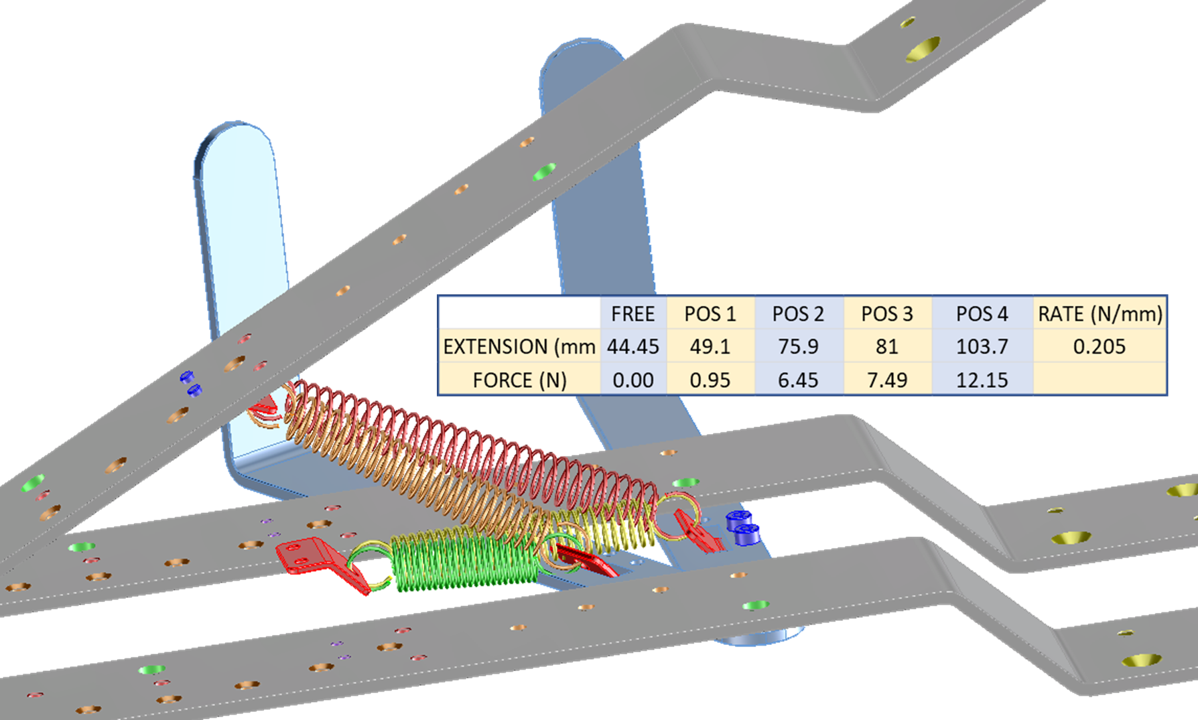

Figure 8: Screenshot showing different spring positions and the spring force v distance starting point calculations.

## Clamping Arms.

Not all the holes in the three identical *Clamping Arms* (*see Figure 5*) are needed for prototypes but are there to help layout for the high-volume manufacturing version. The four holes in the lower arms allow attachment to a table or base plate. Holes in the upper arm allow for customised attachments (not shown here) to improve bag emptying, and to allow compensation for different sizes or models of BVM.

The arms are made from 2mmx40mm flat stock material with four bends and drilled or tapped holes. The arms are raised using motor power, but the compression is controlled by an extension spring. The centre arm is raised 6mm by rotating the bearing block 90 degrees. This is to allow room for the sensors and adjustment levers.

Figure 6: Three identical Clamping arms (unfolded version in red)

## .

## Motor Assembly.

The Motor Assembly raises the centre arm but is not involved in forced air delivery (for safety). This arrangement allows for a range of motors and motor speeds - it needs a minimum speed to allow the arm to stay ahead of the bag opening.

The motor runs on 12v DC and requires a low enough *RPM* (Revolutions Per Minute) so the arm rises at manageable speed (starting test speed: 30 *RPM*). No complicated motor control or narrow motor selection is required since the motor does not apply pressure to the bag (that is the job of the spring). The motor merely raises the clamping arm allowing the bag to inflate spontaneously.

Figure 7: Screenshot of the motor and sensor assemblies.

## Bearing Assembly.

The Bearing Assemblyallows space for different configurations: drilled blocks, solid or roller bearings. The blocks also form part of the base and all three are identical (to improve cost at high volume production). The middle bearing block is rotated 180 degrees generating 6mm clearance on the centre arm. Threaded holes in the blocks facilitate arm attachment and are used to lock the bearing shaft with longer screws. The bearing shaft is 10mm diameter and is identical to the shaft used for the door hinge. An M4 tapped hole in one end of the bearing block allows cover attachment.

Figure 8: Screenshot of the bearing assembly.

## Limit Switch Operation.

Three trip switches *Stop, Pause* and *Start* control the operation and timing of the ABVM (*See Figure 9*). Since it´s assumed the patient will exhale spontaneously, mechanical assistance is only required on inhalation.

The *Pause Switch* stops the motor when the clamping arm is fully open (held by the cam plate). A signal (caused either by the patient starting inhalation or after a set timer delay) re-starts the motor (*CCW*).

The *Stop Switch* stops the motor and there is now a clear path for the arm to pass by the cam plate as the spring pulls the arm thus performing the compression cycle of the arm.

At the end of the compression cycle the *Start Switch* is tripped and starts the motor (*CCW*) causing the arm to open until it is stopped by the Pause Switch.A picture containing table, indoor, toy, various

Figure 9: Screenshot indicating the three limit switches.

## **PROBLEMS TO BE SOLVED (HOW TO HELP)**

## Overview of Problems.

In this section we list the known problems, or areas of the design that need more work. It will be updated as we encounter new issues with the design. These problems require knowledge and experience in electrical, medical, and other technical specialties, but that´s not a requirement to solve them. The objective of this project is to provide a functioning design so there´s a lot more prototyping and testing work required. During this process we´ll issue updates but the design will still be dangerous to use until it is fully certified.

## Spring Selection.

**What is the best combination of springs and indent spacing?** The Spring choice depends on the effect of the systems pressure gradients. The spring adjustment lever has evenly spaced indents. This spacing needs to be adjusted depending on the spring selection. The prototype design of *Garage* uses an extension spring, but with adaptation, such as adding a bracket and a method of force adjustment, it could be possible to use a compression spring.

It may be required to balance the forces with additional springs, for example if the weight of the arm and motor leads to too much force. In this case additional springs such as a torsion spring or a spring plate could be employed.

## Trip Switch and Levers´ Hard Stop Spacing.

**What is the ideal indent spacing?** The prototype design of *Garage* has evenly spaced indent positions for the tidal volume adjustment and this spacing will need to be adjusted depending on how the bag reacts. The first prototype has evenly spaced holes, but the expectation is that the spacing will need to be adjusted.

## Plastic Bag Cover (Hygiene) when covers not used.

**Will this work?** In environments with low resources *Garage* could be used without covers by employing a plastic bag and taping the levers and Clamping Arms.

## Motor and Sensor Selection Guide.

This design can use a range of motors, but what are the motor specifications required? What are the specifications to guide the selection of switches (types and voltage and current)? Are there recommendations on the best choice of motor and switches?

## Wiring Design Layout (Arcing Issues etc).

**Is there an efficient easy to assemble wiring layout?** We hope that the system can be controlled with basic wiring, assembled using a soldering iron and mechanical connectors to achieve a functional machine. The objective is, as much as practical, to avoid using components that need expertise to repair or that are difficult or expensive to acquire. Capacitors are likely required to prevent contact arcing. What safety should be considered in the design?

Figure 10: Proposal for wiring layout design by Jose Francisco Bravo 11MAY20.

## Method of Alarms (Patient Distress and ABVM).

**How can we alert an attendant if the patient becomes distressed and how can we detect this distress?** The system must warn of problems or failure. What´s the best way to do this?

## Method of Patient Signal to Start BVM Compression.

**Could we use a chest strap or a switch arrangement in the airway to send a restart signal to the ABVM?** The system should be able to detect when the patient wants to inhale and use this signal the to start BVM compression stroke. This signal could also be generated with a countdown timer to start the motor that is paused at the top of the cam (see section 2.6 Limit Switch Operation). It is also possible that this could be a manually initiated signal using a push switch.

## Noise Control (Is noise an issue?).

**Is it too noisy?** The motor drive is activated it could cause an impact between the cam and cam plate; the bearings are rough in the *Garage* design. Will these produce unacceptable disruptive level of noise and are they ways to reduce it?

## Documentation: 2D and how-to-make Instructions.

We need help to review the documents (CAD files and this document). The objective is to highlight areas that are unclear or other issues that need to be corrected. For those that cannot open CAD files we need drawings (preferably in .pdf format. *Garage* will not provide detailed manufacturing specifications, but as the design progresses, we need to highlight datums and important tolerances. Later, we´ll need a user guide.

## Patient Requirements in a breathing Emergency (Guidelines for Design).

We need medical advice on the design and the function of the adjustments. This is a document that outlines patient requirements in terms of system design guidelines.

## Emergency Field Guide (if there´s no help what do I need to know)?

This is a document from medical professionals or experts in emergency response that details how the ABVM should be used and how dangerous it can be if used incorrectly. This is for a worst-case scenario.

## **! WARNING!**

## Lung Injury.

* Mechanical Ventilation can cause **serious lung injury**.
* Too much pressure applied to the lungs can stretch and damage them.
* The diaphragm (breathing muscle) can rapidly deteriorate (atrophy) when not used.
* Reduced mucus mobility can lead to harmful build up in the lungs.

## Mechanical Dangers.

* Batteries can electrically shock or cause explosions.
* Springs can store energy that can lead to dangerous projectiles or other impacts.
* Levers can multiply force leading to pinch points capable of causing serious injury.
* Sharp edges can cut or stab people or cause damage to other objects.
* Compressed air or gasses can be dangerously explosive.